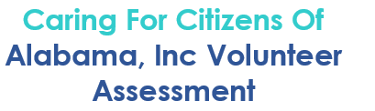
Please complete and return to Caring for Citizens of Alabama Inc Fund / Food Drive and Volunteer
Coordinator 334.239.3518 or FAX to 678.401.0228

Volunteer Information
Date _______________
Application Type
Individual
Group Organization__________________________________# in group _____________
Workplace Company ________________________________________________________
Contact Name ______________________________Contact Number_____________________________
Address ______________________________________________________
City __________________State: _______________ Zip code: _________
Email Address _________________________________________________
Occupation __________________________________________________
Please List any Food or Latex Allergy _______________________________________________________
Hobbies and Skills _________________________________________________________________________
Are you at least 18 years Old? yes no
(Please note that we require one adult 24 or older for every 6 children between the ages of 13 to 18. Sorry, but this kids under 13 cannot participate.)

At this time, we are able to take Court- Order Community Service.
Availability:
8-9:30 AM 9-11:30 AM 8-11:30 1-2:30 PM AM HOURS can be 8-11:30
Monday Tuesday Wednesday Thursday Friday (No shifts after 11:30 AM Fridays)
Interest Area (Check all that apply)
- Sorting and Repacking Donated Products Cooler
- Office Angels (assist with bulk mailers, data entry etc.) Volunteer Fundraising(Fund/
- Special event Support (as needed) Food drives: IFE)
- Professional Consultant (Indicate Interest) ____________________________________________

Caring for Citizens of Alabama, Inc 2424 East South Blvd. Montgomery AL 36116 | 334-239-3518

